Hong Kong Exchanges and Clearing Limited and The Stock Exchange of Hong Kong Limited take no responsibility for the contents of this announcement, make no representation as to its accuracy or completeness and expressly disclaim any liability whatsoever for any loss howsoever arising from or in reliance upon the whole or any part of the contents of this announcement.

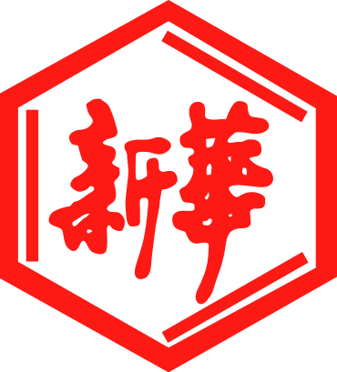

山東新華製藥股份有限公司

Shandong Xinhua Pharmaceutical Company Limited
(a joint stock company established in the People’s Republic of China with limited liability)
(Stock Code: 0719)

ANNOUNCEMENT OF EXTRAORDINARY GENERAL MEETING RESOLUTIONS

At the extraordinary general meeting (the “EGM”) of Shandong Xinhua Pharmaceutical Company Limited (the “Company”) held at No. 1 Lutai Ave., Hi-tech District, Zibo City, Shandong Province, The People’s Republic of China (the “PRC”) on Friday, 28 December 2012 at 9:00 a.m., a poll voting was demanded by the Chairman for voting on the proposed resolutions, as set out in the notice of EGM dated 13 November 2012. All resolutions were approved by shareholders (except that Shandong Xinhua Pharmaceutical Group Company Limited (“SXPGC”) and its associates have abstained from voting in the EGM to approve the ordinary resolution). The board of directors (the “Board”) of the Company is pleased to announce the poll results in respect of the resolutions of the EGM of the Company as follows:
 | Ordinary resolution | No. of Votes  (%) For | No. of Votes  (%) Against | No. of Votes  (%)  Abstained | Total Votes
1. | To approve and confirm the agreement entered into between the Company and Shandong Xinhua Pharmaceutical Group Limited (“SXPGC”) dated 26 October 2012 and the proposed annual caps in relation to the selling of waste materials, water, electricity and steam by the Company and/ or its subsidiaries to SXPGC and/or its subsidiaries and the purchasing of accessories, raw materials and packaging materials by the Company and/or its subsidiaries from SXPGC and/or its subsidiaries in the sum of RMB170,000,000, RMB195,000,000 and RMB230,000,000 for 2013, 2014 and 2015 respectively under such agreement. | 1,182,000  (100%) | 0 | 0 | 1,182,000
 | Special resolution | No. of Votes  (%) For | No. of Votes  (%) Against | No. of Votes  (%)  Abstained | Total Votes
2. | To consider and approve the proposed amendments to Article 147 of the articles of association of the Company. | 167,297,720  (100%) | 0 | 0 | 167,297,720

As at the date of the EGM, the total number of issued shares of the Company is 457,312,830, comprising 307,312,830 A shares listed on the Shenzhen Stock Exchange and 150,000,000 H shares listed on the Stock Exchange of Hong Kong, which was the total number of shares entitling the holders to attend and vote for or against all the resolutions proposed at the EGM. Save for SXPGC, which holds 166,115,720 A shares, representing approximately 36.32% of the total issued share capital of the Company, having abstained from voting the ordinary resolution proposed at the EGM, there were no restrictions on shareholders to cast vote on any of the aforesaid resolutions passed at the EGM.

ShineWing Certified Public Accountants (“ShineWing”), the domestic auditors of the Company, have acted as the scrutineer and performed the procedures agreed with the Company including checking the mathematical accuracy of calculation of the poll results as counted by the Company, comparing the poll results of votes set out in the poll forms to be collected by the Company and providing to the Company the factual findings. The work performed by ShineWing in this respect did not constitute either an audit and accordingly, no assurance was provided, nor advice on matters of legal interpretation or legality of the poll results.

By Order of the Board
Shandong Xinhua Pharmaceutical Company Limited
Zhang Daiming
Chairman
28 December 2012, Zibo, PRC

As at the date of this announcement, the Board comprises:

Executive Directors:  Mr. Zhang Daiming (Chairman)  Mr. Du Deping  Mr. Zhao Songguo | Independent Non-executive Directors:  Mr. Zhu Baoquan  Mr. Bai Huiliang  Mr. Kwong Chi Kit, Victor
Non-executive Directors:
Mr. Ren Fulong
Mr. Xu Lie
Mr. Zhao Bin

